TATA TECHNOLOGIES LTD.
TECH PULSE FY-26 | AI/ML Capstone Project
TECHNICAL REPORT
Field | Details
Institute / University | Pimpri Chinchwad College of Engineering (PCCOE), Pune
Programme / Batch | Digital Track
Student Name | Dhruv Pujari
PRN | 123B1D039
Case Study ID (CS1–CS5) | CS1
Project Title | AUTOSAR HLD Document Analysis Assistant (local LLM + RAG with cited answers)

1. Problem Statement and Intended Users
In car ECU projects, the software design is written in High-Level Design (HLD) documents. These documents are often hundreds of pages long and are saved as PDFs. They explain the software components, ports, interfaces, signals, dependencies and how the functions work together. If an engineer wants one fact, for example which interface a port uses, they have to search through many pages and tables by hand. The same reading is repeated for design reviews, onboarding and test planning. It is also easy to miss mistakes, such as an interface that is used but never defined.
In this project I built a tool that works on these documents on a local computer. The engineer uploads an HLD PDF and asks questions in normal English. The answer comes with the page and section it was taken from. The tool can also make a list of components, interfaces, signals and dependencies, show possible mistakes in the document, and compare two versions of the same HLD. It does not approve anything. Every answer and finding is only a draft until a reviewer accepts, edits or rejects it.
Real HLDs are confidential, so I used synthetic documents that I created in AUTOSAR style. All models run locally, so no document text goes outside the computer.
Intended users: system and AUTOSAR architects, software developers, integration engineers, test engineers and engineering managers. Architects can use it in design reviews, developers and testers can find interfaces and signals quickly, and managers can see what a document contains.

2. Input Data / Knowledge Base
Item | Description
Sources | I used 5 synthetic HLD PDFs written in AUTOSAR style: Door Lock (v1.0 and v1.1), Window Lift, Battery Monitoring and Wiper Control. Each one has an introduction, component sections with port tables, an interface table, a signal list, functional flows and a revision history.  I also made two CSV files (component catalogue and interface list) and the ground truth: the expected inventory, 9 mistakes that I wrote into the documents on purpose, the expected changes between Door Lock v1.0 and v1.1, and 54 test questions. All content is made up. No confidential or OEM data was used.
Size and format | 5 PDFs with a text layer, 9 pages each (45 pages in total), with 41 tables. 2 CSV files and 4 JSON files for the ground truth.  Test set: 54 questions. 16 are direct fact questions, 12 are table lookups, 20 ask for several items (for example, list the ports of a component) and 6 are about things that are not in the documents.
Preprocessing / EDA done | The text is read page by page with PyMuPDF and the tables are read with pdfplumber. Repeated headers, footers and page numbers are removed. Words broken at line ends are joined and extra spaces are cleaned. OCR (Tesseract) is used only when a page has almost no text. None of the 45 pages needed it.  After ingestion there were 109 chunks and 41 of them were tables. A chunk had about 45 words on average (smallest 10, largest 98). There were no duplicate chunks.  I noticed that the sections are short, so the chunks end at the end of the section and never reach the 500 token limit. Table text is stored twice, once inside the section chunk and once as a table chunk.
Chunking strategy | I split the text at numbered headings, for example "3.2 Swc_KeyFobRx". If a section is longer than 500 tokens (about 375 words), it is split again with an overlap of 80 tokens. Each table is kept as its own chunk with its section title and page number.  Every chunk also stores the document name, version, page, last page, section title and type (text or table). This is how the answer can show the page, and how the search can be limited to one version.

3. Solution Architecture

Component | Choice (name, version, hosting)
Pre-trained model | Llama 3.1 8B Instruct, 4-bit (Q4_K_M), run locally with Ollama. Temperature 0.1 and context size 8192. No external API is used.
Embedding model | BAAI/bge-small-en-v1.5 (384 dimensions) from sentence-transformers. It runs on the CPU.
Vector store (FAISS / ChromaDB) | ChromaDB, saved on disk, cosine distance, one collection for each project. I chose it over plain FAISS because I needed filters on version and document.
RAG pipeline / AI-agent design | A simple Python pipeline written by me, without any agent framework. It takes the top 5 chunks, removes chunks with a score below 0.35, puts the rest in a prompt, asks the model and then checks the citations. If no chunk is good enough, it answers "not found" and does not call the model. Entity extraction is a separate step that runs only when the user asks for it.
Service layer and UI | FastAPI for the backend, Streamlit for the screen, and SQLite for documents, findings, answers, reviews and the audit log. Python 3.11. A Docker Compose file (ollama, api and ui) is included in the Model_Prompts_Config folder.
Tools / deterministic rules | Regex rules for the names (Swc_, If_, Sig_) to cross-check the extracted names. Pydantic to check the JSON from the model. An extracted name is kept only if it appears in the source text. A small rule engine finds undefined interfaces, unknown dependencies, signals with no consumer or no producer, signals linked to unknown components and unused interfaces. It can also compare two versions.

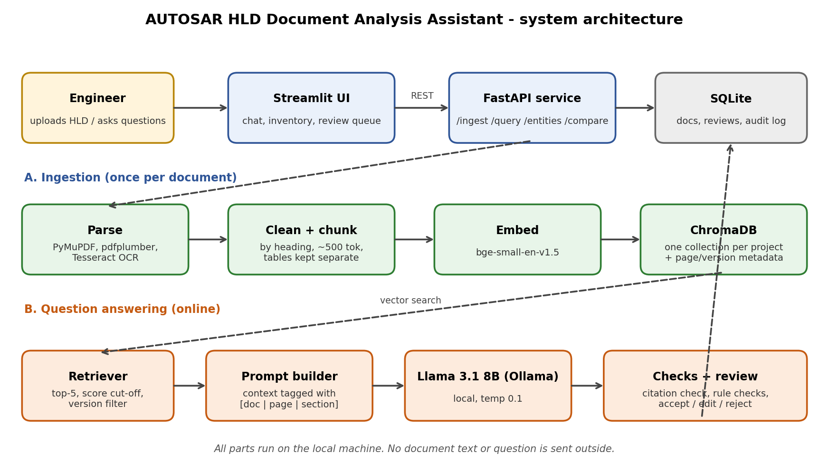
Figure 3.1: System architecture. The engineer uses the Streamlit screen, FastAPI does the work, ChromaDB stores the vectors and SQLite stores the reviews and the audit log.

4. Implementation and Configuration
Step 1: Ingestion. The PDF is uploaded with a project name and a version label. It is read, cleaned and split into chunks as explained in section 2. Each chunk is converted to a vector with bge-small and saved in ChromaDB with its page and section. The counts and an audit entry are saved in SQLite.
Step 2: Retrieval. The question is converted to a vector in the same way and the 5 closest chunks are taken. Chunks with a score below 0.35 are thrown away. If nothing is left, the answer is "Not found in the uploaded documents" and the model is not used. This saves time and avoids made-up answers.
Step 3: Answer. The chunks that are left are numbered S1 to S5. Each one has a tag with document, version, page and section. They are put in the prompt together with the question. The prompt tells the model to use only this text, to write the source tag after each statement, to keep names exactly as written, to ignore any instructions inside the text and to reply NOT_FOUND if the answer is missing. The model runs with temperature 0.1.
Step 4: Checking the answer. The tags in the answer are read back. If a tag does not match a retrieved chunk, or there is no tag, the confidence is low. If the tags are fine, the confidence is high when the best score is 0.60 or more, and medium otherwise. The screen shows the answer, the confidence, the time taken and the text of each source. The answer is saved as pending.
Step 5: Extraction and checks. This runs only when the user asks for it. Each chunk is sent to the model with a request for JSON output. The JSON is checked with Pydantic and names that are not in the chunk are dropped. Names that follow the naming pattern but were missed by the model are added by regex. The results are joined into one inventory per document and the rule engine finds the possible mistakes. Two inventories can be compared to see what changed between versions.
Step 6: Review. The reviewer can accept, edit or reject each answer or finding and add a note. Uploads, questions, extractions, exports and review decisions are written to the audit log.
Key parameters (they are all in config.yaml, so a run can be repeated):
Parameter | Value
LLM / temperature / context | Llama 3.1 8B Instruct Q4_K_M / 0.1 / 8192
Embedding model | BAAI/bge-small-en-v1.5 (384 dimensions)
Chunk size / overlap | 500 tokens / 80 tokens (about 375 / 60 words)
Top-k | 5
Score cut-off / high-confidence score | 0.35 / 0.60
Prompt version | v1.0 (prompts.yaml)
Extraction output | JSON, checked with Pydantic, names must be in the chunk text
Rule checks | 6 rules plus version comparison (rules.py)

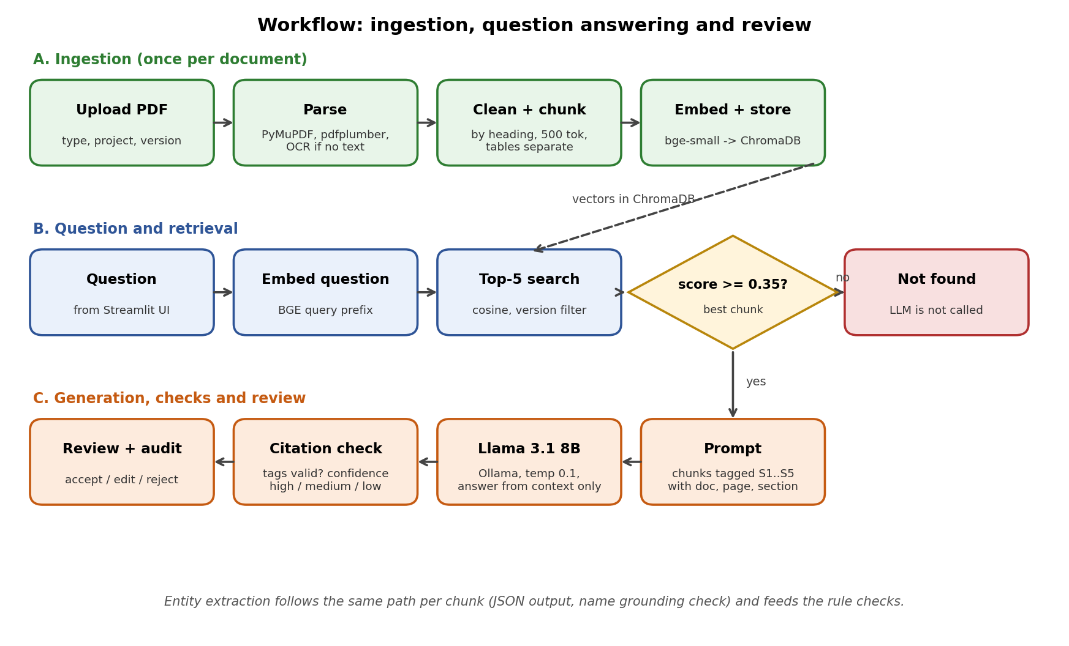
Figure 4.1: Workflow from upload to reviewed answer. If the best score is below 0.35 the system says "not found" directly.

5. Evaluation Steps and Results
Test questions. I made 54 questions together with the documents, so the correct answer and page are known. 48 questions have an answer in the documents: 16 direct fact, 12 table lookup and 20 multi-item questions such as "List the ports of ...". The other 6 ask for things that are not in the documents, for example a CAN baud rate. Each question has the expected words and the expected page. I also stored the expected inventory, the 9 mistakes written into the documents and the expected changes between Door Lock v1.0 and v1.1.
Metrics. Retrieval hit@5 means one of the 5 chunks covers the expected page. Citation accuracy means a cited source covers the expected page. Answer correctness means all expected words are in the answer. I also measured the "not found" rate, precision, recall and F1 of the extracted entities and port links, defect recall, false alarms and the time per question.
Run. All numbers are from one baseline run of scripts/evaluate.py with --ingest and --extract on the 5 documents and 54 questions. I used the settings in config.yaml as they are and did not tune anything to get better scores. The result files are in the Evaluation_Results folder. I show question answering, extraction and rule checking separately because they gave very different results.
# | Test question / scenario | Expected answer / behaviour | Result (Pass/Fail, notes)
A1 | Direct fact (16 questions). Example: Which interface does port Rp_KeyFobReq of Swc_DoorLockCtrl use? | Answer has the interface name and cites the correct document and page. | Pass. 16 of 16 correct (100%).
A2 | Table lookup (12 questions). Example: Which component produces the signal Sig_DoorLockState? | Answer has the producer and cites the signal list page. | Pass. 12 of 12 correct (100%).
A3 | Multi-item (20 questions). Example: List the ports of Swc_DoorLockCtrl. | Answer has every expected name. | Partly failed. 17 of 20 correct (85%). All 3 wrong answers of the test set are in this group.
A4 | Not in the documents (6 questions). Example: What is the CAN baud rate used by Swc_DoorLockCtrl? | Reply "Not found in the uploaded documents" with no made-up value. | Pass. 6 of 6 returned "not found" (100%).
A5 | Citation check on the 48 answerable questions | A cited source covers the expected page of the expected document. | Partly failed. 41 of 48 correct (85.4%). In 7 answers the cited page was different from the expected one.
R1 | Rule engine on the expected inventories of the 4 v1.0 documents (no LLM) | 9 mistakes: 3 in Door Lock, 2 in Window Lift, 3 in Battery Monitoring and 1 in Wiper Control. None in Door Lock v1.1. | Pass. 9 of 9 found, none extra.
R2 | Version comparison of Door Lock v1.0 and v1.1 using the expected inventories (no LLM) | 10 differences: new component and interface, renamed interface with its port changes, one removed and one new signal. | Pass. 10 of 10 found.
R3 | Rule engine on the inventories extracted by the LLM (full pipeline) | The same 9 mistakes as in R1. | Mostly failed. 3 of 9 found (33%). Door Lock 1 of 3, Window Lift 0 of 2, Battery Monitoring 2 of 3, Wiper Control 0 of 1.
R4 | Version comparison of Door Lock v1.0 and v1.1 using the inventories extracted by the LLM (full pipeline) | The same differences as in R2. | Partly worked. Precision 0.54, recall 0.88, F1 0.67.

Metric | Score / observation
Retrieval hit@5 (48 answerable questions) | 100% (48 of 48)
Citation accuracy | 85.4% (41 of 48)
Answer correctness, overall | 93.8% (45 of 48)
Answer correctness by type | Fact 100% (16/16), table 100% (12/12), multi-item 85% (17/20)
Correct "not found" (6 questions) | 100% (6 of 6)
Entity extraction recall (5 documents) | Components, interfaces and signals: 1.00 in every document. Port links: 0.63 to 1.00.
Entity extraction precision (range) | Components 0.33 to 0.44, interfaces 0.44 to 0.80, signals 0.57 to 0.80, port links 0.26 to 0.50. Per document below.
Entity extraction F1, average of the 5 documents (range) | Components 0.57 (0.50 to 0.62), interfaces 0.79 (0.62 to 0.89), signals 0.82 (0.73 to 0.89), port links 0.51 (0.37 to 0.67).
Recall of the intended mistakes (from the extracted inventory) | 3 of 9 (33%). Door Lock 33.3%, Window Lift 0%, Battery Monitoring 66.7%, Wiper Control 0%. Door Lock v1.1 has no intended mistakes.
Defect false alarms | 17 in total: Door Lock v1.0 5, Window Lift 3, Battery Monitoring 3, Wiper Control 2, Door Lock v1.1 4. A false alarm is a finding that is not one of the 9 intended mistakes.
Version comparison, Door Lock v1.0 vs v1.1 (extracted inventories) | Precision 0.54, recall 0.88, F1 0.67
Model output and name check | The JSON was valid in every call (0 errors). The name check removed 16 names that were not in the text and the regex added 13 names that the model had missed.
Time per question | Median 18.06 s, maximum 42.56 s (local 8B model)

Entity extraction and defect detection for each document (inventory extracted by the LLM compared with the expected inventory):
Document | Components F1 | Interfaces F1 | Signals F1 | Port links F1 | Defect recall
DoorLock v1.0 | 0.500 | 0.800 | 0.800 | 0.370 | 33.3%
WindowLift v1.0 | 0.615 | 0.800 | 0.800 | 0.435 | 0%
BatteryMonitor v1.0 | 0.615 | 0.889 | 0.889 | 0.667 | 66.7%
WiperControl v1.0 | 0.533 | 0.615 | 0.889 | 0.560 | 0%
DoorLock v1.1 | 0.588 | 0.833 | 0.727 | 0.516 | n/a (no defects)

Precision and recall for each document (P / R) and the number of false alarms:
Document | Components P / R | Interfaces P / R | Signals P / R | Port links P / R | False alarms
DoorLock v1.0 | 0.333 / 1.00 | 0.667 / 1.00 | 0.667 / 1.00 | 0.263 / 0.625 | 5
WindowLift v1.0 | 0.444 / 1.00 | 0.667 / 1.00 | 0.667 / 1.00 | 0.312 / 0.714 | 3
BatteryMonitor v1.0 | 0.444 / 1.00 | 0.800 / 1.00 | 0.800 / 1.00 | 0.500 / 1.00 | 3
WiperControl v1.0 | 0.364 / 1.00 | 0.444 / 1.00 | 0.800 / 1.00 | 0.389 / 1.00 | 2
DoorLock v1.1 | 0.417 / 1.00 | 0.714 / 1.00 | 0.571 / 1.00 | 0.364 / 0.889 | 4

Reading the results. Question answering works well on my test set. The right page was retrieved for every question, 45 of 48 answers were correct and all 6 questions that cannot be answered were refused. The weaker parts are the citations (in 7 of 48 answers the expected page was not cited) and the multi-item questions, which are the only type with wrong answers.
Extraction behaves differently. It finds everything that is really there (recall is 1.00 for components, interfaces and signals in all 5 documents), but it also adds many wrong entries. So precision is low (components 0.33 to 0.44) and F1 is only 0.50 to 0.62. Port links are weaker still, with precision of 0.26 to 0.50. The Inventory screen for Door Lock v1.1 (Figure 5) shows the kind of wrong entries. The model listed ordinary words such as "key fob", "application layer" and "software components" as components, the words "Interface" and "Signal" as an interface and a signal, and a port name (Pp_LockCmd) as a signal. The rules run on this inventory, so the wrong entries create false alarms (17 in total). All 4 findings in Figure 5 are false alarms, because that document has no intended mistakes.
Only 3 of the 9 intended mistakes were found. I have not checked every missed mistake yet. In Wiper Control all port links were found but the mistake (an unknown dependency) was still missed, so the dependency information from the model may be the problem there. The rule engine itself works correctly, as R1 shows. I kept the results as they came and did not change the settings to improve them.
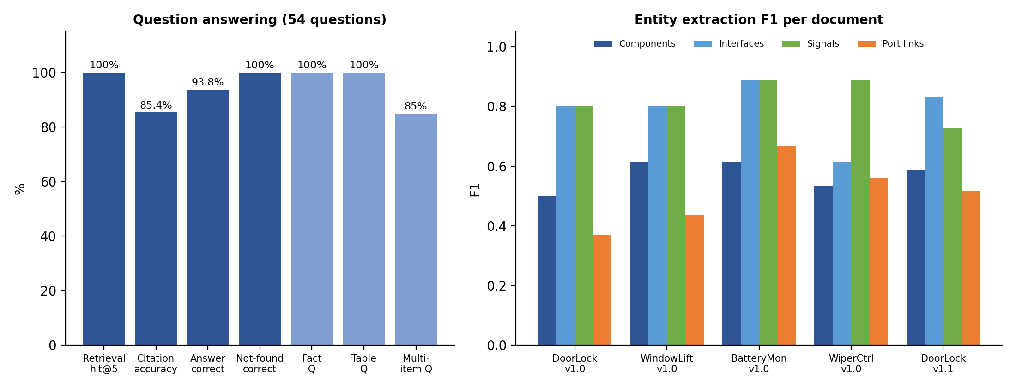
Figure 5.1: Question answering results (left) and entity extraction F1 for each document (right).

6. Responsible AI Measures
Area | Measure adopted in this project
Grounding and citations | The model may use only the retrieved text and must give a source tag (document, version, page, section) for its statements. If a tag does not match a retrieved chunk, the confidence becomes low. If the search result is weak or the model says NOT_FOUND, the system answers "not found" instead of guessing. Extracted names are kept only if they appear in the source text.
Privacy | The language model, the embedding model, the vector store and the database all run on the local computer. No document text or question is sent to an outside service. Only synthetic documents were used. Each project has its own collection, so documents of different projects are not mixed.
Security | The API can use a shared token (set through an environment variable), only PDF files are accepted and file names are cleaned. The prompt tells the model to treat document text as data and to ignore instructions inside it, which reduces the risk of prompt injection. Login, role-based access and encryption are not implemented. I list them as future work.
Human oversight / review | Nothing is final. Answers and findings are saved as pending and a reviewer accepts, edits or rejects them with a note. The confidence label comes from the search score and the citation check, not from the model's own opinion. The audit log records every upload, question, extraction, export and review with the user name and time.

7. Innovation Highlights
- Not found check before the model. If no chunk is good enough, the system says "not found" without calling the model. This is faster and avoids made-up answers. I tested it with 6 questions.
- Citation check. Every source tag in the answer is compared with the chunks that were really retrieved. The confidence label comes from the search score and this check.
- Checked extraction. The model output must follow a JSON format and each name must be present in the chunk text. Names that the model misses are added by simple regex rules.
- Rules separate from the model. The consistency checks and the version comparison are normal Python code, so the results are the same every time and can be tested.
- Test data with the answers included. A script creates the HLD PDFs and, at the same time, the expected inventory, the mistakes written into the documents, the expected version changes and 54 questions with page numbers. This made the evaluation repeatable without confidential documents.
- Review screen and audit log. Answers and findings can be accepted, edited or rejected on the screen, the inventory can be exported as CSV or JSON, and every action is logged.

8. Screenshots, Logs and Evidence
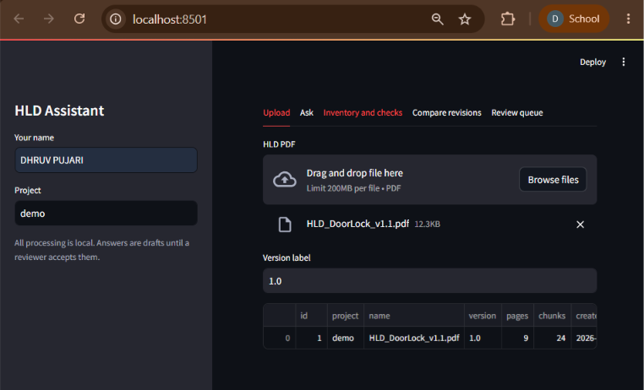
Figure 1: Upload tab. HLD_DoorLock_v1.1.pdf is ingested into the project "demo" (9 pages, 24 chunks).

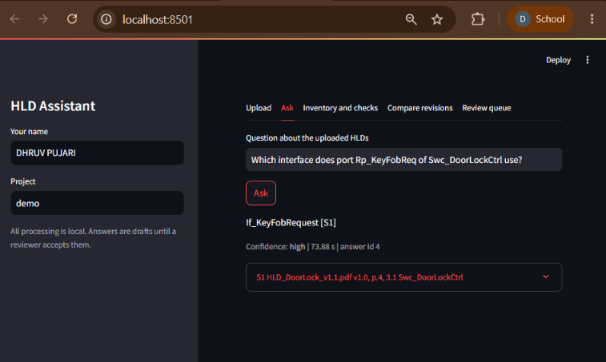
Figure 2: Ask tab. The answer has the source tag [S1], a confidence label and the time taken. The source line shows the document, page 4 and the section 3.1 Swc_DoorLockCtrl.

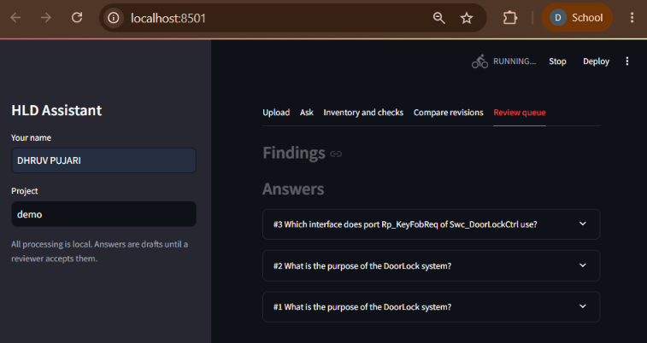
Figure 3: Review queue. The answers waiting for a reviewer decision (status pending).

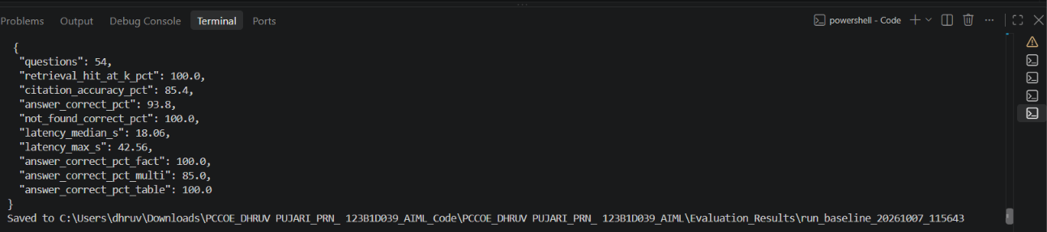
Figure 4: Summary printed at the end of the baseline evaluation run: 54 questions, 100% retrieval hit, 85.4% citation accuracy, 93.8% answer correctness and 100% correct "not found".

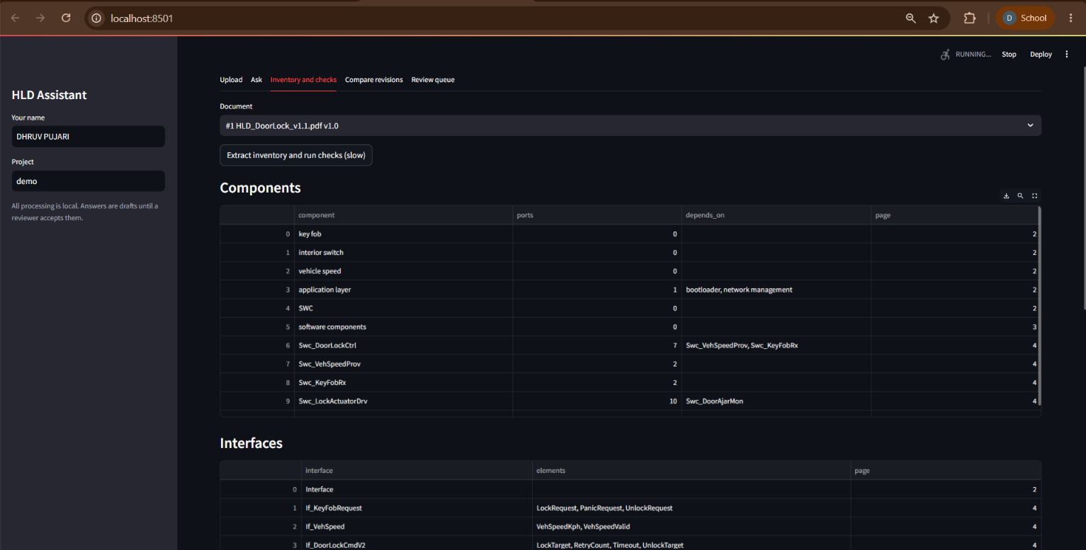
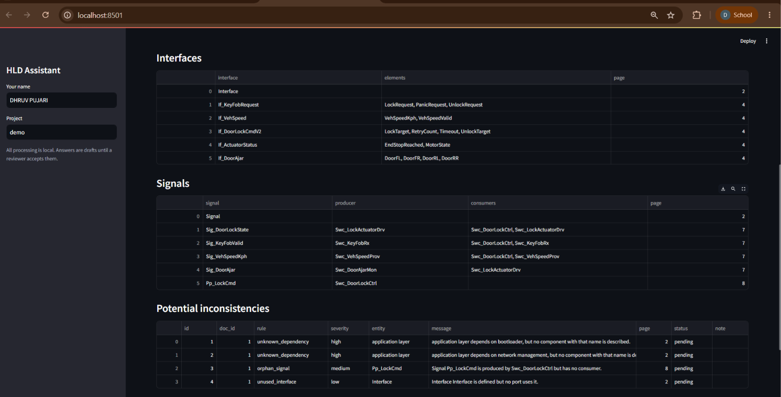
Figure 5: Inventory and checks tab for HLD_DoorLock_v1.1.pdf. Top: components and interfaces. Bottom: signals and the table of potential inconsistencies (all with status pending).

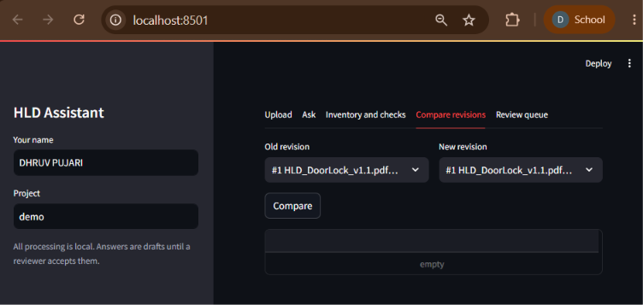
Figure 6: Compare revisions tab. The same document (#1) is selected as old and new revision, so there are no differences and the result table is empty.

9. Reflection and Conclusions
What I learned. Good chunks matter more than anything else in a RAG system. Splitting by section and keeping the tables separate helped a lot, and the right page was found for all 48 answerable questions. One accuracy number can hide problems. Question answering got 93.8% correct, but extraction with the same model was much weaker, so each part has to be checked separately. Creating the test questions and the answers together with the documents made it easy to repeat the evaluation.
Challenges. Page headers and page numbers got into the chunks, so I had to remove them first. Tables lose their rows when the text is extracted normally, so I extract them separately. The hardest part was extraction with a small local model. It found all the real components, interfaces and signals, but it also listed many wrong ones, so precision was low (components 0.33 to 0.44) and F1 was between 0.50 and 0.62. The name check only makes sure a name is written in the chunk, it does not check what kind of name it is, so ordinary words from the text were accepted as components. The rules work on the extracted inventory, so the wrong entries became false alarms (17 in total) and only 3 of the 9 intended mistakes were found. I have not checked every missed mistake yet.
Limitations. The documents are synthetic and short (9 pages each). Real HLDs will be longer and messier. 3 of the 54 answers were wrong (all multi-item questions) and in 7 of 48 answers the cited page was not the expected one. Diagrams in PDFs are not read, only text and tables. The name rules (Swc_, If_, Sig_) fit my synthetic documents and need to be changed for another naming style. A median time of 18 seconds per question (maximum 42.6 seconds) is slow for normal use. Correctness is checked by matching words, so a correct answer with different wording could be marked wrong. There is no login, role-based access or encryption.
Future improvements. Look at the failed questions in qa_results.csv and try small changes in min_score, top_k and chunk size. Read the port and interface tables with a table parser instead of the model, accept only names that follow the naming pattern (Swc_, If_, Sig_), and add examples to the extraction prompt. Try a bigger model or another embedding model, add a reranker, read diagrams, add login and access control, and test on approved real HLDs with architects.

10. AI-Tool Usage Declaration
AI tool / model | Purpose | Artifact affected
Claude (Anthropic) | Help with writing and fixing the Python code (ingestion, API, Streamlit, evaluation script) and with the Docker files. | Code/, Model_Prompts_Config/ (Dockerfile, compose, prompt wording)
Claude (Anthropic) | Help with drafting the synthetic HLD text, the question generator, the synopsis and this report. I checked and edited the content. | Input_Data/ (synthetic documents, ground truth), Synopsis and Documentation

11. Student Declaration
I confirm that this report represents my own understanding and contribution, that the work follows the approved case-study scope, and that I can explain every significant part of the implementation.

Signature: |  | Date: | 07/10/2026
Name: | Dhruv Pujari | PRN: | 123B1D039

